SQL Case Study 2: Burger Bash


INTRODUCTION:
I have a started a new business of selling burger because I read on my Instagram feed that „Burger Is the Future!
But I knew that burger alone was not going to help me get seed funding to expand my new Burger Empire - so I had one more genius idea to combine with it - I was going to Uberize it - and so Burger Runner was launched!
I started by recruiting “runners” to deliver fresh burger from Burger Runner Headquarters and also maxed out my credit card to pay freelance developers to build a mobile app to accept orders from customers.

SCHEMA USED

burger_runner runner_id int registration_date date
customer_orders
order_id int
customer_id int
burger_id int
exclusions varchar
extras varchar
order_time timestamp

runner_orders
order_id | int
runner_id | int
pickup_time | timestamp
distance | varchar
duration | varchar
cancellation | varchar

burger_names
burger_id | int
burger_name | varchar

CASE STUDY QUESTIONS

- How many burgers were ordered?
SELECT COUNT(*) AS total_burgers_ordered
FROM customer_orders;



- How many unique customer orders were made?
SELECT COUNT(DISTINCT order_id) AS unique_orders
FROM customer_orders;



- How many successful orders were delivered by each runner?
SELECT runner_id, COUNT(*) AS successful_orders
FROM runner_orders
WHERE cancellation IS NULL
GROUP BY runner_id;

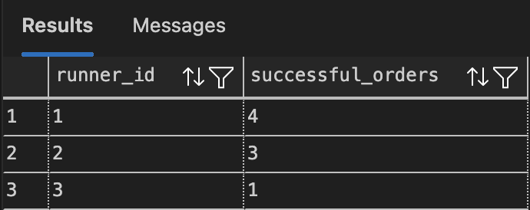
- How many of each type of burger was delivered?
SELECT bo.burger_name, COUNT(*) AS total_delivered
FROM customer_orders co
JOIN burger_names bo ON co.burger_id = bo.burger_id
JOIN runner_orders ro ON co.order_id = ro.order_id
WHERE ro.cancellation IS NULL
GROUP BY bo.burger_name;

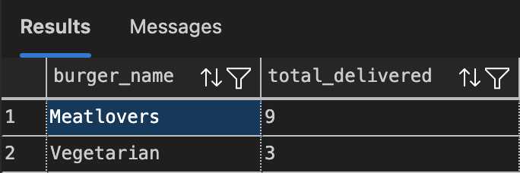

- How many Vegetarian and Meatlovers were ordered by each customer?
SELECT co.customer_id, bn.burger_name, COUNT(*) AS burger_count
FROM customer_orders co
JOIN burger_names bn ON co.burger_id = bn.burger_id
GROUP BY co.customer_id, bn.burger_name;

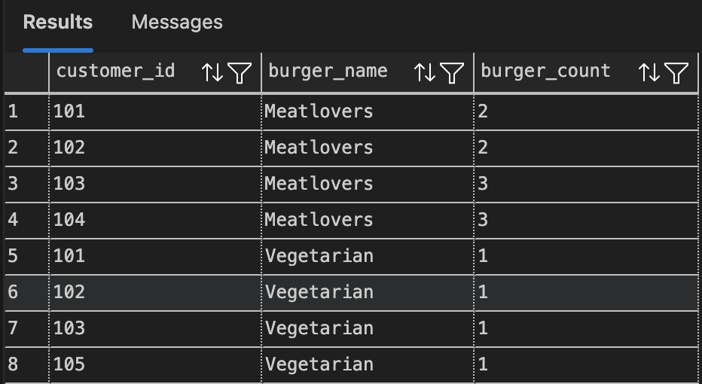

- What was the maximum number of burgers delivered in a single order?
SELECT TOP 1 order_id, COUNT(*) AS burger_count
FROM customer_orders co
JOIN runner_orders ro ON co.order_id = ro.order_id
WHERE ro.cancellation IS NULL
GROUP BY co.order_id
ORDER BY burger_count DESC;



- For each customer, how many delivered burgers had at least 1 change and how many had no changes?
SELECT customer_id,
SUM(CASE WHEN exclusions IS NOT NULL OR extras IS NOT NULL THEN 1 ELSE 0 END) AS changed_burgers,
SUM(CASE WHEN exclusions IS NULL AND extras IS NULL THEN 1 ELSE 0 END) AS unchanged_burgers
FROM customer_orders co
JOIN runner_orders ro ON co.order_id = ro.order_id
WHERE ro.cancellation IS NULL
GROUP BY customer_id;


- What was the total volume of burgers ordered for each hour of the day?
SELECT DATEPART(HOUR, order_time) AS order_hour, COUNT(*) AS total_burgers
FROM customer_orders
GROUP BY DATEPART(HOUR, order_time)
ORDER BY order_hour;

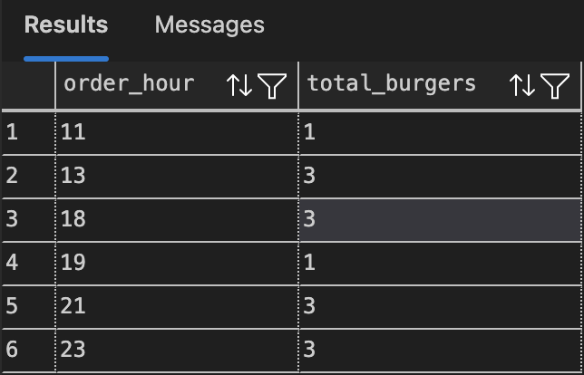

- How many runners signed up for each 1 week period?
SELECT
DATEADD(WEEK, DATEDIFF(WEEK, 0, registration_date), 0) AS week_start,
COUNT(*) AS runners_signed_up
FROM burger_runner
GROUP BY DATEADD(WEEK, DATEDIFF(WEEK, 0, registration_date), 0)
ORDER BY week_start;



- What was the average distance travelled for each customer?

SELECT co.customer_id,
ROUND(AVG(CAST(REPLACE(ro.distance, 'km', '') AS FLOAT)), 2) AS avg_distance_km
FROM customer_orders co
JOIN runner_orders ro ON co.order_id = ro.order_id
WHERE ro.cancellation IS NULL
GROUP BY co.customer_id;

